WEBSITE PROJECT PROPOSAL & SUBMISSION DOCUMENT
Ethey's Fashion Feaster
HTML & CSS Website Project

Table of Contents
- 1. Project Overview
- 2. Website Goals and Objectives
- 3. Target Audience
- 4. Website Features and Functionality
- 5. Design and User Experience
- 6. Technical Requirements
- 7. Sitemap and File Structure
- 8. Timeline and Milestones
- 9. Budget
- 10. Testing and Quality Checks
- 11. References and Asset Source Log
- Appendix A: Second Project Proposal

1. Project Overview
Organisation: Ethey's Fashion Feaster
Ethey's Fashion Feaster is a fictional Limpopo-based fashion boutique created for this academic website project. The organisation focuses on stylish, practical and affordable clothing for women, men and children. The website is intended to give customers a clear way to discover collections, learn about the organisation, make product enquiries and find contact information.
The project follows the assignment requirement to create a small/medium website with a minimum of five web pages, semantic HTML structure, an external CSS stylesheet, responsive design, organised assets and a functional navigation system. The final website contains six pages: Home, About Us, Products, Enquiry, Contact and Sitemap.

2. Website Goals and Objectives
- Present Ethey's Fashion Feaster professionally online.
- Make products and collections easy to discover.
- Provide clear information about the organisation, mission and vision.
- Provide an enquiry form for product and customer-service questions.
- Provide contact information for more than one location.
- Create a responsive interface that works across desktop, tablet and mobile screen sizes.
- Use accessible, readable content and consistent navigation throughout the website.
Key performance indicators (KPIs) for a future live deployment include page visits, product-page engagement, completed enquiries, contact interactions and mobile usability.

3. Target Audience
The primary target audience is local and online fashion customers looking for affordable clothing for themselves or their families. The website is designed for adults who shop for women's and men's clothing as well as parents/guardians shopping for children's clothing. The layout prioritises straightforward navigation, readable information, visible calls to action and simple enquiry functionality.

4. Website Features and Functionality
Page | Required content/functionality
Home | Hero image, introductory message, calls to action, value propositions and organisation story.
About Us | Organisation history, mission, vision and values.
Products | Women's, men's and children's collections with descriptive content, illustrative prices and enquiry links.
Enquiry | HTML form for name, email, phone, enquiry type and message.
Contact | Two proposed store locations, addresses, phone numbers, email details and hours.
Sitemap | Visual representation of the website structure and linked navigation.

5. Design and User Experience
The visual design follows the supplied Ethey's Fashion Feaster reference: a black navigation and footer, gold accent colour, white and warm cream content areas, large fashion imagery and strong headings. The design uses card layouts for collections and values, consistent buttons for calls to action, and generous spacing for readability.
Colour palette: Ink black (#101010), gold (#D6A900), warm cream (#FBF8F0), white (#FFFFFF), and neutral grey text. Typography uses a clean system sans-serif stack so the website remains self-contained and does not depend on external font services.
Responsive design uses CSS Grid, Flexbox, relative sizing and media queries. On smaller screens, multi-column layouts become single-column layouts and the navigation wraps for accessibility.
The supplied enquiry photograph is included as a local image asset on the Enquiry page. Other local fashion images are included in the ZIP so the site does not rely on broken external image URLs.

6. Technical Requirements
- HTML5 semantic structure including header, nav, main, sections, forms and footer.
- External CSS3 stylesheet linked to every page.
- No JavaScript is used, in accordance with the requested project constraint.
- Relative links are used between all pages so the website works from the extracted folder.
- All image files are stored locally in the images folder.
- Responsive CSS media queries support desktop, tablet and mobile layouts.
- HTML form fields use labels, appropriate input types and required validation attributes.

7. Sitemap and File Structure
The main navigation hierarchy is: Home → About Us → Products → Enquiry → Contact, with Sitemap available in the footer.
The website root contains index.html, about.html, products.html, enquiry.html, contact.html and sitemap.html. The css folder contains style.css; images contains all local visual assets; wireframes contains the homepage and sitemap planning diagrams; docs contains the source log.
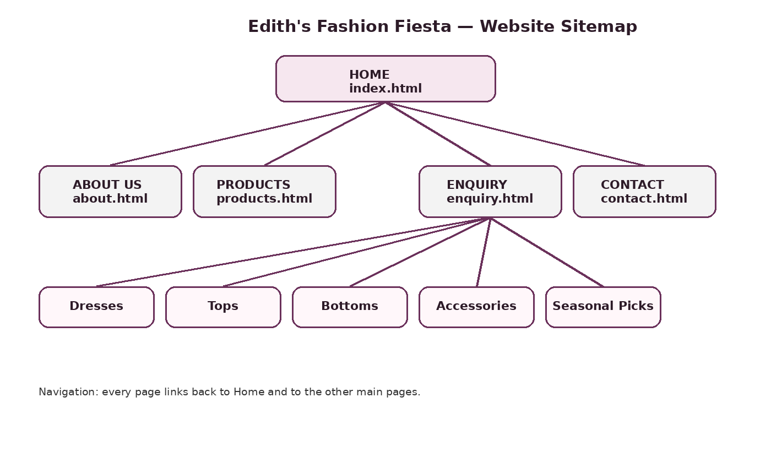
Sitemap planning diagram included in the website package.

8. Timeline and Milestones
Period | Activities | Milestone
Week 1 | Project planning, target organisation selection and proposal. | Approved proposal and project scope
Week 2 | Content research, asset collection and sitemap planning. | Content/source log and wireframe
Week 3 | HTML foundation and page navigation. | Six linked HTML pages
Week 4 | CSS styling, typography, layout and responsive design. | Styled desktop/tablet/mobile website
Week 5 | Testing, corrections, documentation and submission preparation. | Final ZIP, README and submission document

9. Budget
The following figures are realistic planning estimates for an academic prototype and can be adjusted after lecturer feedback.
Item | Estimated cost (ZAR) | Notes
Domain name | R200–R350/year | Typical .co.za domain estimate
Basic hosting | R80–R180/month | Entry-level shared hosting estimate
Development | R0 | Academic project; student-developed HTML/CSS
Maintenance | R300–R600/month | Illustrative future content/update allowance

10. Testing and Quality Checks
- Checked that all six HTML pages are present.
- Checked that the shared navigation points to the correct filenames.
- Checked that footer links use the same relative paths.
- Checked that local image references point to files inside website/images.
- Checked that every page links to css/style.css.
- Checked form fields for labels and required attributes.
- Designed responsive breakpoints for desktop, tablet and mobile layouts.
- Confirmed that no JavaScript file or JavaScript code is required.

11. References and Asset Source Log
The assignment screenshots supplied in the project conversation were used as the basis for the structure, terminology and requirements of this document and website. The supplied Ethey's Fashion Feaster visual reference was used as the design direction. The enquiry photograph was supplied in the conversation and is included locally in the website.
No external web assets are required for the final local website. The source-log.txt file records the image and asset treatment.

Appendix A: Second Project Proposal
Alternative target organisation: Makhado Fresh Bake — fictional local bakery
Makhado Fresh Bake would be a small local bakery website aimed at customers who want fresh bread, cakes, pastries and celebration orders. The proposed website would establish a professional online presence while keeping the information simple and accessible. The organisation overview would explain the bakery's focus on fresh products, friendly service and community customers. Its mission would be to provide reliable, affordable baked goods, while its vision would be to become a trusted local bakery for everyday purchases and special occasions.
The website goals would include increasing awareness, presenting the product range, encouraging enquiries for custom cakes and providing clear opening hours and contact details. Useful KPIs could include page visits, enquiry submissions, cake-order requests and contact interactions. The proposed pages would include Home, About Us, Products, Enquiry and Contact. The Home page would feature a large bakery image, short introduction and call-to-action. Products would group breads, pastries and cakes. Enquiry would capture customer name, contact details, order type and message. Contact would provide at least two proposed collection locations.
The design would use warm cream, dark brown and a restrained accent colour, with readable typography and strong visual hierarchy. CSS Grid and Flexbox would be used for the desktop layout, with media queries for smaller screens. The project would use HTML and CSS only, with local images and an organised folder structure. A realistic timeline would cover planning, research, HTML structure, CSS styling, responsive testing and final documentation. This alternative proposal is included because the assignment material states that two project proposals should be prepared before selecting the organisation to take forward.

